

Product Catalog System

How to create a supplier
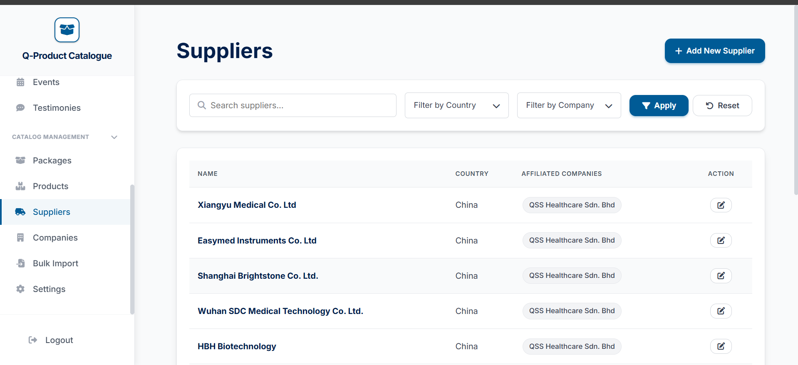

Go to the suplier tab


Click on the add new suplier button at the top

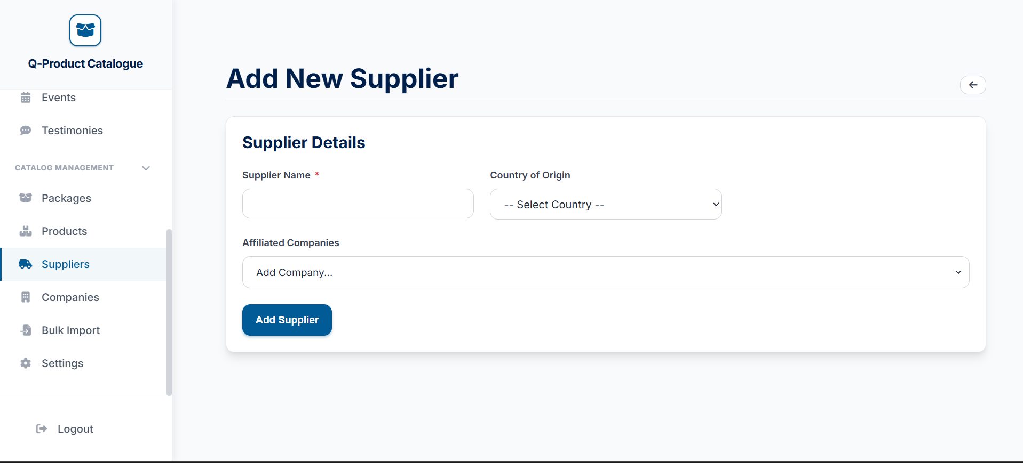
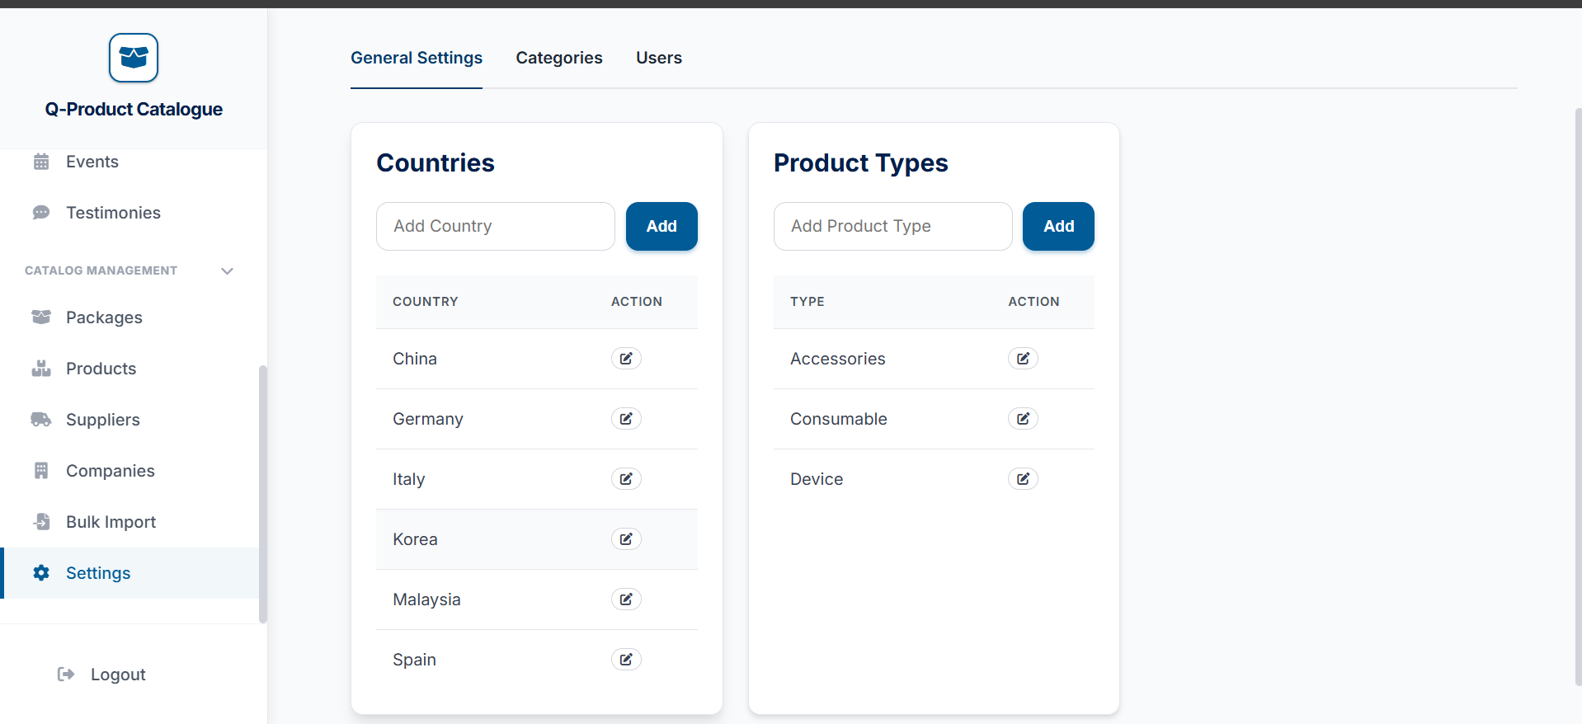

After filling, just press the add suplpier button
Fill out this form and the details that are starred are required to fill
Enter the country you want here
Enter the country you want here


Enter the country you want here

